Ezio Auditore: The Hero’s Journey
Game Story Analysis

Ezio Auditore da Firenze is a fictional character of the Renaissance past. He is the main character of Assassin’s Creed II, Assassin’s Creed II: Discovery, and Assassin’s Creed: Brotherhood (also to star in the upcoming Assassin’s Creed: Lost Legacy 3DS title).

Ezio’s variant of The Hero’s Journey spans for twenty-three years, starting when he was seventeen in 1476 and getting to a conclusion when he gets forty years old in 1499. And this is the main reason why I’ve chosen him as the main target of my Hero’s Journey Game Story Analysis – in real life we all have our own life-long version of the Hero’s Journey, and it is not until the end is getting closer that we realize what life we have led and how much we’ve changed.

Most parts (and certainly the most important ones) of Ezio’s Journey are depicted in Assassin’s Creed II, but I will also reference both Discovery (takes place during the Assassin’s Creed II timeframe) and Brotherhood (which digs deeper into the relationship between Ezio and Cristina Vespucci during Assassin’s Creed II timeframe).

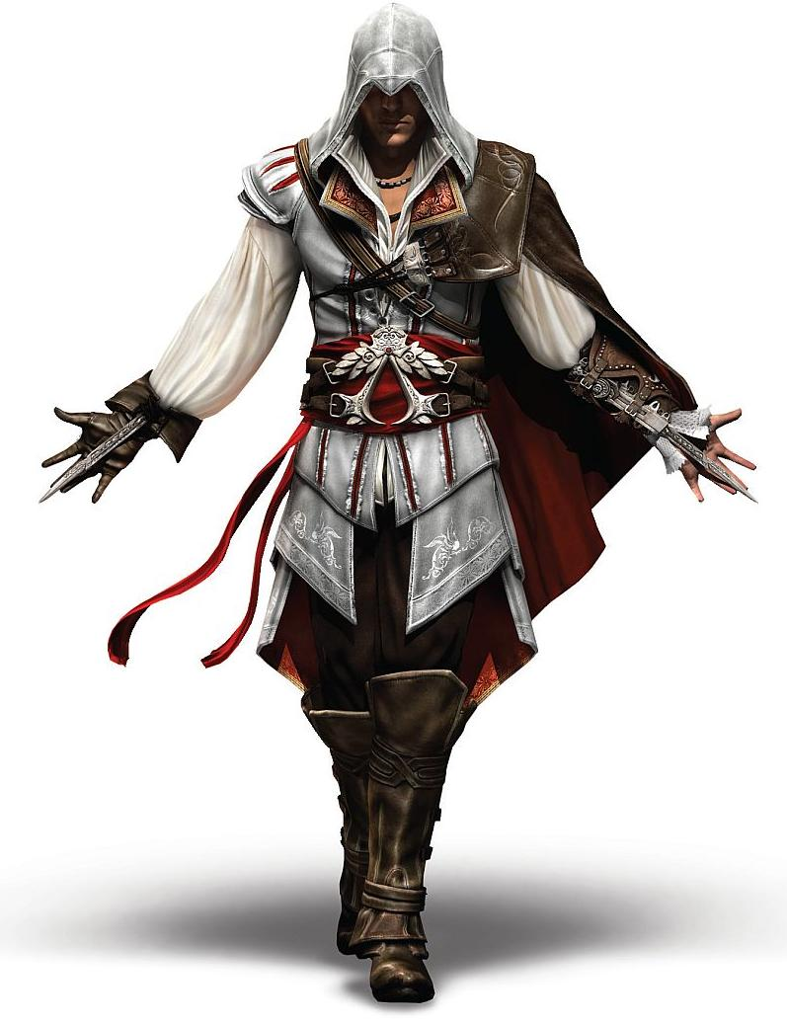
CHARACTER ARCHETYPES
THE HERO – Ezio Auditore da Firenze
Ezio Auditore is the Unwilling Anti-Hero. He is quite content with leading a rich life of a, supposedly, banker, and has a quite sceptical attitude towards any changes. The mantle of the Hero is forced upon him as heritage after his family was executed – the mantle of the Assassin, a man who protects and serves the people from the shadows.

It takes a whole lifetime for Ezio to grow as a character: from a teenage boy who cowardly wanted to satisfy his desire for revenge to a wise adult man who discovers that it is the choices in life, not fate, defines one’s destiny, and sacrifices his own freedom to unravel the source of the Conspiracy which tries to take control of all Italy.

THE MAIN MENTOR – Mario Auditore
Ezio’s Uncle, Mario is one of the Multiple Mentors that Ezio has. Though an Assassin himself, Mario is too old to wield the mantle of the Hero. That’s why I would call him the ‘Main’ one: he doesn’t partake the most active part in Ezio’s Journey, but motivates him to finally accept the Call to Adventure and teaches not only to respect one’s own self, but also one’s adversaries.

THE MENTORS –
Paola, La Volpe, Antonio, Teodora, Bartolomeo d’Alviano, Niccolò Machiavelli
Ezio Auditore is an example of a Hero who has Multiple Mentors. They all are, unbeknownst to Ezio until a certain point, Assassins. But, it is worthy of note that the Assassin Order is pretty much in decay during the events of the game, and Ezio, being the youngest Assassin initiate, is the hope of its full-fledged revival.

THE ALLY – Leonardo da Vinci
Leonardo da Vinci is Ezio’s best friend, and, probably, the closest thing to a brother he had for the most of his life. Leonardo and Ezio are very protective of each other, and, even though Leonardo is not a man of violence, he actively helps Ezio as much as he can, usually by creating a machine or mechanism of some sort.

THE SHADOW – Rodrigo Borgia
Also known as ‘the Spaniard’, Rodrigo Borgia is the leader of the Templar Order planning to gain power over the people of Europe. Being the main person responsible for the execution of the Auditore family, Rodrigo is the main target of Ezio’s vendetta. He represents Ezio’s hunger for vengeance, which Ezio, during his Journey, eventually defeats and overcomes.

THE THRESHOLD GUARDIANS – The Conspirators
Almost each target that Ezio has to assassinate is a Threshold Guardian of one kind or another. On the surface, they act as barriers for Ezio as he tries to unravel the Conspiracy, but they also represent some of Ezio’s inner demons, and through passing these guardians Ezio finds his own answers to different questions: of morale, of respect, of power, of choice, and others.

THE SHAPESHIFTER – Cristina Vespucci
Cristina Vespucci is not a literal Shapeshifter in her own right. In fact, she doesn’t even take a very active part in Ezio’s Journey. But, being Ezio’s love, Cristina still represents change. She is Ezio’s anchor in the Ordinary World even after he already entered the Special one, and she gets farther away as the story progresses until the chains are finally broken by her death.

THE TRICKSTER – Minerva
It’s hard to find a character in Assassin’s Creed II which would perfectly fit the general Trickster archetype, but Minerva is certainly the person who played the biggest joke on Ezio. After spending all his life to uncover the Templar Conspiracy, to learn what it was for and to actually find the Vault that Rodrigo Borgia tried to enter; after actually accomplishing all that, Ezio receives a metaphorical slap in the face from her.

THE HERO’S JOURNEY
- It is a good life we lead, brother.
- The best. May it never change.
- And may it never change us.
- Frederico and Ezio Auditore, 1476; Assassin’s Creed II, Sequence 1

The Ordinary World (1476, Florence; Sequence 1 | AC:B – Cristina Memory 1)
Ezio Auditore da Firenze leads a life he’s content with as a son of a banker. He’s introduced to Leonardo da Vinci – a man who will eventually become young Auditore’s best friend. Ezio also meets Cristina Vespucci, the love of his life.

Ezio’s Journey: Ezio is introduced as a charming and protective, but careless young man. Maria even scolds him for not having found a meaning in his life.

The Call to Adventure (1476, Florence; Sequence 1)
Ezio’s family is betrayed by a close friend of his father, Uberto Alberti. Ezio’s father instructs his son to get into a secret room in the Auditore mansion. There Ezio finds the equipment of an Assassin and letter containing proof of innocence. Still, Ezio is unable to save his father and brothers from being hanged and vows to avenge their death.

Ezio’s Journey: Ezio receives the Call when he opens the hidden chest. The Call to Adventure for Ezio is the Call to accept his heritage and continue the work of his father by serving the greater good. But Ezio’s blinded by lust for vengeance.

Crossing the First Threshold (1476, Florence; Sequence 2 | AC:B – Cristina Memory 2)
With the help of Ezio’s first met Multiple Mentor, Paola, Ezio kills Uberto in a state of rage. Ezio, aided by Cristina, gives the Last Rites to his executed family. Ezio intends to flee the city and asks Cristina to go with him, but Cristina refuses, as she doesn’t want to hurt her own family. Ezio gives her a necklace to remember him by.

Ezio’s Journey: Ezio has crossed the First Threshold by making his first kill, but does not yet commit to the Adventure. He’s in the state of refusal, intending to flee to Spain.

- But what about your father? He’d want you to finish his work.
- What work? My father was a banker.
- Wait… He did not tell you?
- Mario and Ezio Auditore, 1476; Assassin’s Creed II, Sequence 3

Meeting the Mentor (1476, Monteriggioni; Sequence 3)
Ezio leads his sister and shocked mother out of Florence and seeks a refuge in the Auditore family villa in Monteriggioni. Ezio’s Uncle Mario gives them shelter and tells Ezio about the Assassin Order and his heritage, asking him to stay, train, and continue his father’s work of unraveling the Conspiracy set in motion by the Templar Order.

Ezio’s Journey: Mario explains the meaning of the Call to Ezio. Ezio, being driven by his instincts and not responsibility, is afraid to accept it.

Refusal of the Call (1476, Monteriggioni; Sequence 3)
Ezio refuses, wanting to take his family to Spain. After spending some time in the villa Ezio learns more about his family and ancestors and eventually accepts his heritage.

Ezio’s Journey: Mario teaches Ezio to respect his ancestors as well as his enemies, a lesson without which Ezio wouldn’t be able to enter the Special World.

Tests, Allies, Enemies (1478-1482, Monteriggioni, Florence, San Gimignano, Forli, Venice; Sequence 4-8 | AC:B – Cristina Memory 3)
Ezio sets up to end the Conspiracy. However, the first thing he does after returning to Florence is meeting with Cristina, who, upon her father’s infusion, was to be married. Ezio leaves after making sure her future husband loves her. Ezio identifies Rodrigo Borgia as the leader of the Conspiracy and tracks him to Venice. Ezio travels with Leonardo to Venice. During this period, Ezio meets some of his other mentors: La Volpe and Antonio.

Ezio’s Journey: Ezio realizes that he has to leave the person he loves back in the Ordinary World. This was the first of many things he had to adjust for. We also see as Ezio’s hate narrows only towards Rodrigo Borgia himself. Ezio doesn’t kill guards without necessity, and even though the Conspirators are his leads to Rodrigo, he disposes of them not only for his own sake.
- It’s been over ten years since I watched my father and brothers die. Ten years hunting the men responsible. I’m so close to the end now, but… no closer to understanding what any of it was for!
- Ezio Auditore, 1488; Assassin’s Creed II, Sequence 11

Approach to the Inmost Cave
(1486-1488, Venice; Sequence 9-11 | AC:B – Cristina Memory 4)
Ezio learns that Cristina’s visiting Venice. Ezio meets with her, but Cristina criticizes him for not carrying for her feelings and asks him to never talk with her again. Ezio, with new allies such as Teodora and Bartolomeo d’Alviano, learns more about Rodrigo Borgia’s goals and poses as a guard carrying a prize the Spaniard was looking for all this time.

Ezio’s Journey: To fully secure his place in the Special World, Ezio has to sacrifice his heart’s desire of having a normal, peaceful life with the woman he loves. After that he is ready to approach the goal of his quest.

Supreme Ordeal (1488, Venice; Sequence 11)
Ezio confronts Rodrigo and is almost overwhelmed by him and his guards, but is saved by all the mentors who come out of the shadows and drive Borgia away. Ezio then meets Niccolò Machiavelli, who reveals that all his mentors were part of the Assassin Order.

Ezio’s Journey: Ezio is on the brink of death itself, as he is not ready to face the Shadow, due to his yet incomplete transformation. But, with the help of his allies, Ezio survives and realizes he is not alone in his quest.

Reward (1488, Venice; Sequence 11)
Even though Ezio is frustrated that Rodrigo escaped, the Assassins take possession of the mysterious Apple of Eden, an artifact that would allow Borgia to rise to power. Ezio is formally inducted into the Order.

Ezio’s Journey: Induction into the Order of the Assassins means that Ezio has completed his training and has learned all the rules of the Special World, ready to finally transform both himself and the World around him.
- Killing you won’t bring my family back. I’m done.
- Ezio Auditore, 1499; Assassin’s Creed II, Sequence 14

The Road Back (1488-1498, Forli, Florence, Venice; Barcelona, Zaragoza, Granada; Sequence 12 | ACII:D )
A monk Savonarola managed to wound Ezio and steal the Apple of Eden. While searching for the Apple, Ezio had to make a small detour to Spain, until he returned to Florence where Savonarola used the Apple to command people.

Ezio’s Journey: Ezio now puts responsibility to the Order in front of his thirst for vengeance and personal goals.

Resurrection (1498, Florence; Sequence 13 | AC:B – Cristina Memory 5)
Ezio finds wounded Cristina. Before dying, she shows Ezio the necklace he gave her all those years ago. Ezio retakes the Apple into his possession and learns that Rodrigo was looking for the Apple to open a Vault in Vatican. Ezio decides to get to it before the Templars do.

Ezio’s Journey: Cristina’s death makes Ezio fully accept the change both within and around him. Ezio learns the importance of freedom and choice, and finally lets go of his hate.

Return With the Elixir (1499, Rome; Sequence 14)
In Vatican, Ezio confronts Rodrigo, now Pope Alexander VI. Even though Ezio is tempted to kill the bastard, Ezio leaves him alive as it won’t change the past. Ezio enters the Vault where he discovers Minerva, who, whoever, doesn’t explain much to him.

Ezio’s Journey: Ezio is now fully transformed – this helps him to overcome the desire for revenge. With the Shadow defeated, Ezio’s variant of the Hero’s Journey comes to an end.

- There are certain moments a man never forgets. His first kiss. His first duel. But most of all, the moment he first discovers his purpose in life.
- Ezio Auditore; ‘Ezio’s Destiny’ Trailer

