

Keeping Connected
www.savannahprimaryschool.blogspot.com 21st April, 2011


PTA Update
Upcoming events:
- Fun Day and Raffle – Sat. June 11th. Please sell as many raffle tickets as you can – this is a MAJOR fundraiser!

Well Done!
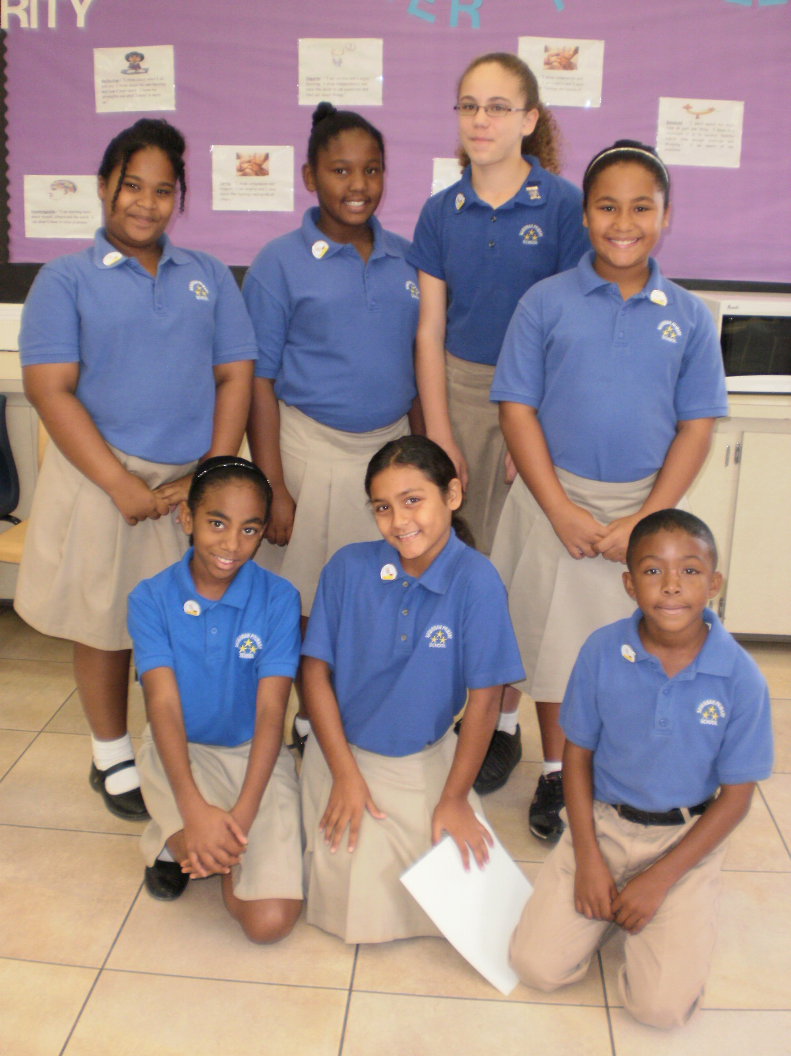
…to Zachary Linwood (Y3W), Nikayla Elliott (Y4WE), Kaelyn Oliver (Y4WE) and Aliyah Christian (Y4C), Kimone Bogle (Y6W), Andrew Brooks (Y6W), Jonathan Miller (Y3W) and Nicole Ewers (Y5G) for showing integrity by handing in lost money to the office. STUDENTS WHO LOSE MONEY SHOULD COME TO THE OFFICE TO FIND OUT IF IT HAS BEEN FOUND. Any money not claimed is given to the PTA.

Library Assistants
Congratulations to Hunter Luke (Y6D), Joshua McField (Y5R), Monique Hernandez (Y5G), Cynthia Hydes (Y5G), Deandra Whitemen (Y5R), Nelissa Terry (Y5R) and Brianna Bodden (Y5R) who have completed their training as Library Assistants and were pinned at assembly on Wednesday. There are now 23 Library Assistants who work with Miss Peart at lunchtimes to manage and organise the library. Children in Y5 and Y6 are eligible for training and should discuss their interest with Miss Peart.

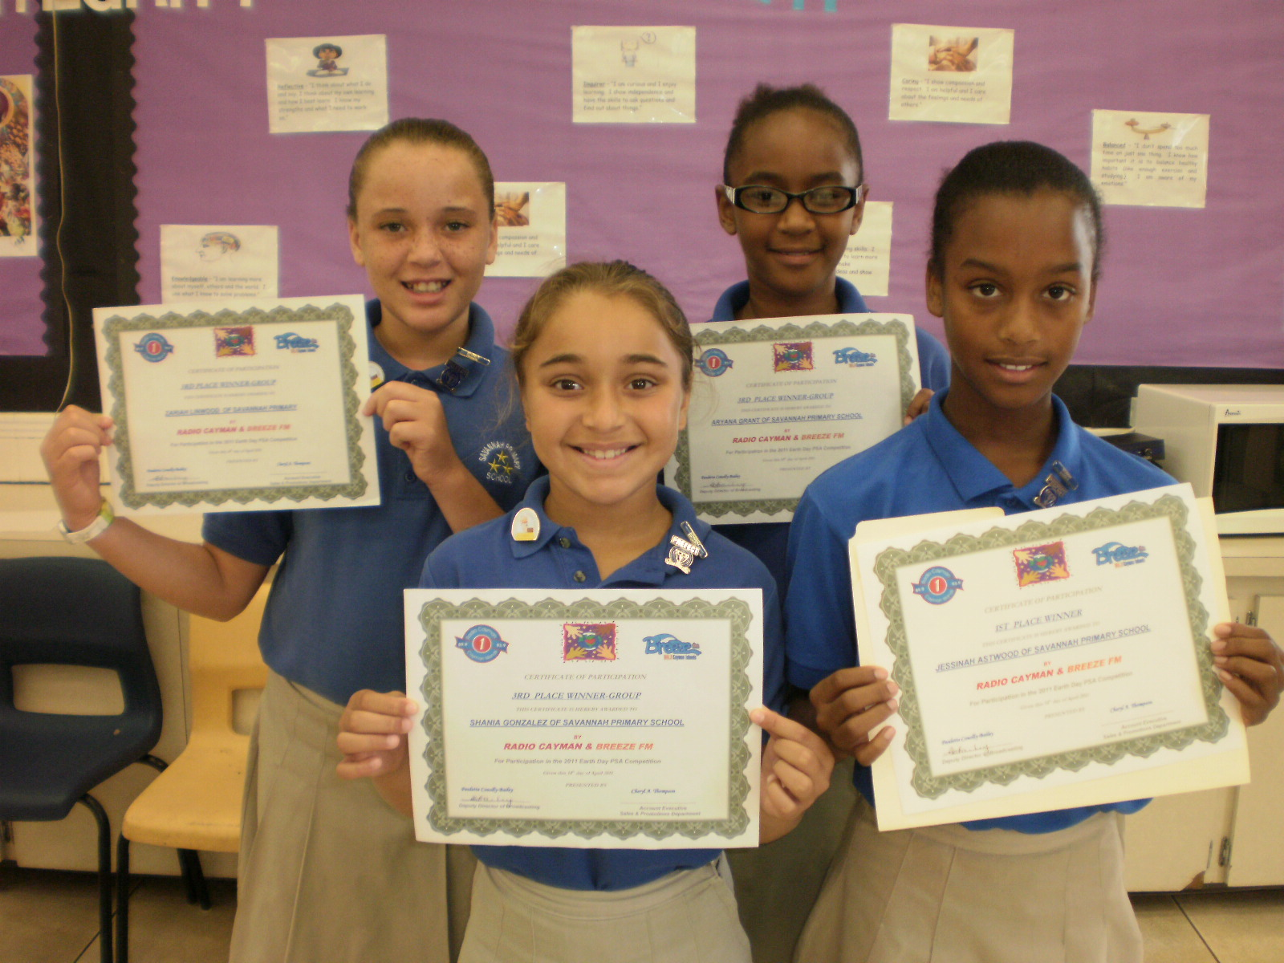
Public Service Announcement Competition
Each year, students from Y6 at Savannah Primary School participate in the Radio Cayman and Breeze FM PSA competition for Earth Day. The winners visit the radio station and record their announcements which are then broadcast to the general public.

Savannah Primary’s PSAs were scheduled to air, on both Radio Cayman 89.9FM and Breeze 105.3FM, at:
- 5:30pm Monday, April 18 Jessinah Astwood
- 3:45pm Wednesday, April 20 Joelyn Scott
- 7:30am Friday, April 22 Aryanna Grant, Shania Gonzalea, Zariah Linwood & Kimberly Hall

Missed them? Don’t worry! They can also be heard at www.radiocayman.gov.ky .

Red Cross – Red, White and Do Box
All Y3 – Y6 students have been given a box home today from the Red Cross. May is Red Cross Month and they would like your support to raise funds. The children are asked to do chores and put their ‘pay’ in the box to help others less fortunate than themselves.
An Easter Carol
Tomb, thou shalt not hold Him longer;
Death is strong, but Life is stronger,
Stronger than the dark, the light,
Stronger than the wrong, the right,
Faith and Hope triumphant say
Christ will rise on Easter Day.

Phillips Brooks, 1893
Have a Wonderful Easter Break!

NCFA – Speech Awards
Congratulations to all our competitors in the NCFA Speech Competitions. We were awarded the following awards in the Standard English Solos and Choral Speech sections.

GOLD: Ethan Watler (Y6W); Aliyah Powell (Y2S); and Dequan Smith (Y3W)

SILVER: Aryana Grant (Y6D); Zariah Linwood (Y6D); Vitoria Buttrum (Y5G) and Craig Maitland (Y2C)

BRONZE: Nazia Jacques (Y3W); Jennay Camacho (Y3N)

SPEECH CHOIR – Silver

House Points
Well done, Nightingale! Following the introduction of house points a few weeks ago, we have totaled the points for the end of term as follows:

Nightingale - 206
Swallow - 204
Man O' War – 182

Well done to all students who have worked hard and impressed their teachers and other adults around the school with their behaviour and commitment to their work. Nightingale’s reward was to have a free Dress Down Day on the last day of term.

Please note that we are also awarding house points to children whose parents attend PTA meetings. We would encourage you all to support your child and their house by coming out and attending these meetings. Please always remember to sign in so that your points can be added and counted.

Dates for your Diary
Thurs., Apr. 21st School closes for Easter break at 1pm
Mon., May 2nd School reopens for the summer term
Wed., May 4th Start of the NCFA Ensembles and Bands Competition
Thurs., May 5th
and Fri., May 6th IB Authorisation Visit
Mon., May 16th Local Holiday – Discovery Day – school closed
Mon., May 23rd –
Fri., May 27th Key Stage 2 tests – Y6 only
Fri. May 27th Dress Down Day
Mon., June 6th –
Fri., June 10th Terra Nova Tests – Y2 – Y6
Sat., June 11th PTA Fun Day
Mon., June 13th Local Holiday – Queen’s Birthday
Fri., June 24th Dress Down Day
Wed., June 29th Leaver’s Ceremony 10am – venue to be confirmed
Thurs., June 30th School closes for the summer holidays at 1pm

