

Keeping Connected
www.savannahprimaryschool.blogspot.com 8th April, 2011


Field Trips and Visitors…
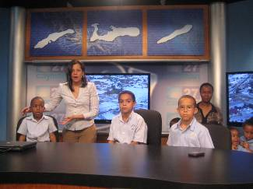
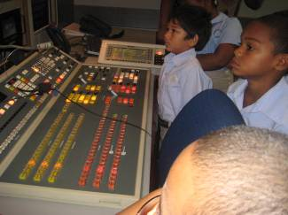
This week Y2 visited CITN – and were very excited to be there! They were able to see how a TV recording studio operates and had a chance to experience what it is like to be a news reader.
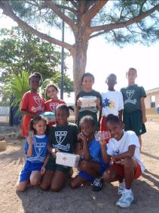
Y3 concluded their Unit of Inquiry by undertaking an orienteering and first aid challenge around the school grounds. They were able to put much of what they have learned during their Unit of Inquiry – “X Marks the Spot” – into practice as they navigated their way around the school grounds. They had to find and treat an injured person. A fabulous way of demonstrating their knowledge and skills!
PTA Update
Upcoming events:
- Fish Fry – Fri., Apr. 15th – your help is required! Please return the form sent out by the PTA with your offer of support either with preparation, items, money or on the evening itself.
- Fun Day and Raffle – Sat. June 11th. Please sell as many raffle tickets as you can – this is a MAJOR fundraiser!
- Next meeting – Mon., Apr. 18th. The topic of Homework will once again be the focus – please come and complete our discussion on this important issue.

Dates for your Diary
Mon., Apr. 11th –
Fri., Apr. 15th Week of the Young Child
Tues., Apr. 12th Start of NCFA Preliminaries
Thurs. Apr.. 14th Student-led Conferences
Mon., Apr. 18th PTA Meeting
Thurs., Apr. 21st School closes for Easter break at 1pm
Mon., May 2nd School reopens for the summer term
Wed., May 4th Start of the NCFA Ensembles and Bands Competition
Thurs., May 5th
and Fri., May 6th IB Authorisation Visit
Mon., May 16th Local Holiday – Discovery Day – school closed
Mon., May 23rd –
Fri., May 27th Key Stage 2 tests – Y6 only
Fri. May 27th Dress Down Day
Mon., June 6th –
Fri., June 10th Terra Nova Tests – Y2 – Y6
Sat., June 11th PTA Fun Day
Mon., June 13th Local Holiday – Queen’s Birthday
Fri., June 24th Dress Down Day
Wed., June 29th Leaver’s Ceremony 10am – venue to be confirmed
Thurs., June 30th School closes for the summer holidays at 1pm
Thank you…to Andrew Watler (Y4E) for donating a book to the library…and to Joel Lyn (Y4E) for contributing $1.25 towards the purchase of a book.

Maths Moment

One of the major changes in the way we are teaching numeracy is the teaching of a range of mental strategies to students.

Here are the main strategies that your child will be learning. Once they have been introduced to the strategies, they can choose whichever method makes the most sense to them. There is more than one way to get the answer – and it is important that the children find a method that they understand and can work successfully with. Sound mental calculation comes before the introduction of traditional, compact written methods.

Partitioning:
e.g. 34 + 35 = (30 + 4) + (30 + 5)
(30 + 30) = 60
(4 + 5) = 9
= 69

Compensation:
e.g. 17 + 9 = 17 + 10 – 1 = 26
26 + 11 = 26 + 10 +1 = 37

Doubles or near doubles
e.g. 8 + 8 = 16
so 8 + 9 = 8 + 8 + 1 = 17

Bridging through 10, 20, etc.
e.g. 8 + 7 = (8 + 2) + 5
= 10 + 5 = 15
15 + 9 = (15 + 5) + 4
= 20 + 4 = 24

Remember these are MENTAL strategies - can you work out
37 + 29
using one of those methods? Do you have another strategy that gets the same answer?

Being able to calculate mentally and explain how you got the answer shows an understanding of number and that is what we are aiming for with our students.

IB Attitude of the Month – Curiosity
Children are naturally curious. Curiosity leads them to learn about their world and test its limits, to find out what's fun and what hurts, and to test their skills while developing new ones.
Encourage this sense of curiosity and inquisitiveness in your children by challenging them to explore the world around them and go beyond their comfort zone -- and even yours! Try something new – a sport, a hobby, an artistic project, a science experiment…
Doing these things will help your kids stay engaged and excited about life and about learning for years to come. Plus, it will help your child become a better problem solver, a free thinker, and a more self-reliant adult.
These qualities help children avoid negative peer pressure and risky behaviour. Fostering creativity also is likely to instil a lifelong love of learning in your child, which will contribute to his or her long-term academic and professional success.

IB Authorisation Visit
We are very pleased to inform you that our IB Authorisation visit has been re-scheduled for Thurs., May 5th and Fri., May 6th 2011. A team of 2 representatives from IB America will spend the days in school finding out about what we do and how we do it in relation to the recommendations for the IB PYP program.

Well Done!
…Elia Eden – for achieving a Gold Certificate from the Principal for her continued commitment to the IB Attitudes and Learner Profile.

