

Keeping Connected
www.savannahprimaryschool.blogspot.com 4th March, 2011


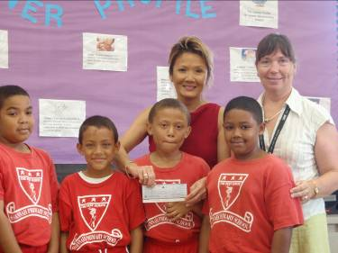
Half-Term Holiday
Please be reminded that there is NO SCHOOL next week for students due to the half-term holiday. Have a great week!

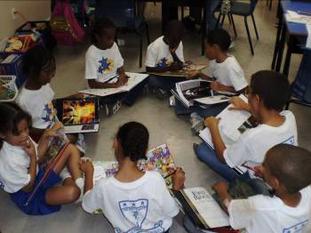
Field Trips and Visitors…
Y3 trip to the George Town Library courtesy of Rotary Central. As part of Rotary Literacy Month, the students were invited to tour the library, be introduced to library mending and how it works, have a story AND receive a free book and snacks. A good time was had by all.

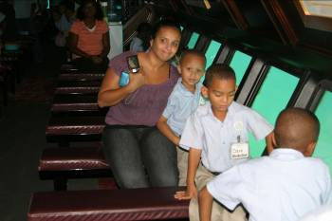
Y1K went on a trip to the Nautilus Submarine. They were able to see lots of sea creatures up close. All 3 year 1 classes also went to Boatswain’s Beach where they were able to handle baby turtles, feed the birds in the aviary and observe the nurse sharks in their tank.

Sports Update
The results are out for this year’s netball league. Our ‘B’ team came 5th and our ‘A’ team came 3rd. Well done to all who participated. The winning teams were: ‘B’ teams – East End Primary School and ‘A’ teams – George Town Primary School. Well done to them both.

Half-Term at KidZone
Kidz Zone will be holding a mid term camp, 7th- 11th March 7:30am - 5:30pm. Cost is $45 per day or $160 for 4 days inclusive of a hot meal. Snacks may be purchased or brought in.

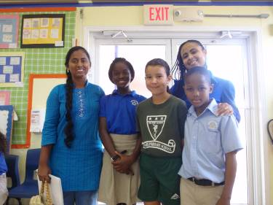
Spotlight Academy
On Thurs., Mar. 3rd, we had a visit from Ms. Fame Verona from Spotlight Academy. The after-school programme was offering a 2 week scholarship to a student in the school who showed an aptitude for the performing arts. This has been offered around all the island’s primary schools. She randomly selected 6 students from the audience who volunteered to perform for the rest of the school – well done to all who were keen to participate. The winning student was selected by the students themselves and the final 3 were Jordae Scott (Y6W), who sang “I Believe I Can Fly”; Rochelle Foster (Y5G) who danced and Joel Lyn (Y4E) who danced and sang. The winner was Joel Lyn.

Please note that Spotlight Academy is running a half-term programme – please contact Fame Verona on 939 2619 for more details or to register.

Dress Down Day Money
The money raised from our special Valentine’s Day Dress Down Day was handed over on Wednesday, March 2nd to Dr. Sook Yin a Director of the Cayman Heart Fund. We were delighted to be able to hand over in excess of $720.
Well Done!
…to Charles Clifford 1K and Timothy Maldonado-Ebanks 1K for being enthusiastic about learning
…to Brianna Dilbert 2S; Elia Eden 2S; Haeli Skeete 2S; Isobel Chipp 1K; Kinsey Miller 5R; Thomas Ramoon 3W and D’Andre Rankin 1H for consistently maintaining IB attitudes
…to Kimone Bogle 6W; Sarafina Mitchell 6W and Jabari Morgan 1K for volunteering to help others
…to Taijah McDermott 4C; Kiandre Rankin 4C ; Rochell Foster 5G and Melissa Myre 5G for having a caring attitude
…to Terika Powell 5R; Edward Thompson 5G; Kolton Miller 5G and Alexander Eden 5G for being committed to working hard
…to Jaydon Gregory 4WE for taking risks in learning
…to Diandra Whittaker (Y3W); Adam Godfrey (Y3N); Daniel Campbell (Y4E); Kimeria David (Y4E); Rochell Foster (y5G); Sascha Broderick (Y5R); Shania Gonzalez (Y6D) and Joelyn Scott (Y6W) for their participation in the PTA meeting on Monday evening – you were stars!

Dates for your Diary
Mon., Mar 7th –
Fri., Mar. 11th (Incl.) Half-term holiday
Mon., Mar. 14th Commonwealth Day
Fri., Mar. 25th Dress Down Day
Mon., Mar. 28th PTA Meeting
Thurs., Mar. 31st and
Fri., Apr 1st Inter-Primary Sports
Thurs. Apr.. 14th Student-led Conferences
Mon., Apr. 18th PTA Meeting
Thurs., Apr. 21st School closes for Easter break at 1pm

PTA Update
Many thanks to all who attended our PTA meeting on Mon, Feb 28th. We had a full agenda. Mrs. Scotland updated parents on the arrangements for next year’s uniforms. Mrs. Rattray led a session with the students talking about IB projects and what they think about them; what support they get; and what they learn from them. Thank you to all 8 (see Well Done above) for their participation. The final item was a presentation from the Ministry and PWD architects on the proposed new classroom block for Savannah Primary School. The 8 classroom and library block should be ready to be used by early 2012, which will support the predicted continued rise in numbers of students attending the school. We hope to put plans up in the canteen for parents to see as soon as we receive them from the architects.

IB Attitude of the Month…Integrity
Integrity is doing the right thing, even when no one else is watching. (Anon.)

