

Keeping Connected
www.savannahprimaryschool.blogspot.com 25th February, 2011


School Sports Day
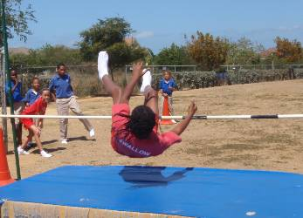
Many, many thanks to Mrs. Scott (PE teacher) for all her work in preparing the children for our sports day last week, for her work in putting the lists of names together for races and for organizing the events on the day. She was inadvertently missed off the thanks on the last newsletter – sorry, Mrs. Scott – and thank you! Thank you also, in advance, for the work she has started to do in preparation for the Inter-Primary Sports on Thurs., Mar. 31st and Fri., Apr. 1st.

Mr. Clarke has already begun the search to find the school’s high-jump representative. Well done everyone for taking a risk and having a go!

Field Trips and Visitors…
Y1 visited Dart Park where they collected and studied “Creepy Crawlers” as part of their IB unit on life cycles. We are delighted to be able to offer our youngest classes so many hands-on experiences which make learning so much more interesting. Today, the Y1O and Y1H students are visiting the Nautilus Submarine. Y1 K will have their trip on Monday.

Year 6 Trip to Cuba

Please be reminded that the deposit of CI$100.00 per person (any person other than a student) needs to be paid by Monday, 28th February. Deposits can be dropped in the "Drop Box" - please ensure that the envelope is clearly marked "Year 6 Cuba Trip.” Also, be reminded that deposits are not required for the Year 6 Students but for any other person that is travelling on the trip (children or adults). Please specify whose names the deposits are to be applied to.

If you have any questions, please feel free to email them to savannahpta@live.com.

Why Should Parents Get Involved in their
Childrens’ Education?
- School age children spend 70% of their waking hours (including weekends and holidays) outside of school.
- Family participation in education is twice as predictive of students’ academic success as family socioeconomic status.
- When parents practice reading at home to the children, the children make significant gains in reading achievement compared to those who only practice in school.
- The more parents participate in schooling on every level – as fundraisers and boosters, as volunteers and para-professionals, as home teachers – the better student achievement.
- When parents are involved students have better grades and graduation rates, better attendance, increased motivation and self-esteem, lower rates of depression, decreased use of drugs and alcohol, fewer instances of violent behaviour.

Assembly – Congratulations!
We had a very busy assembly on Wed., Feb. 23rd with the pinning of the Student Council representatives; the pinning of new library assistants; the awarding of the Sports Cups; and the regular presentation of Principal’s Certificates.
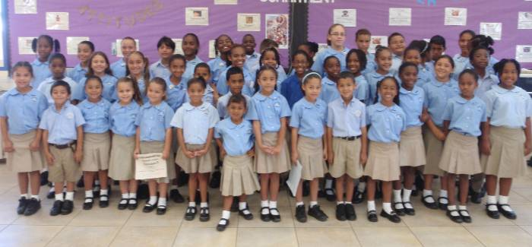
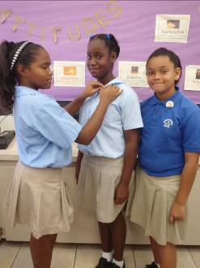
The student council is very ably supported by Miss Peart, our Librarian, who has worked with the Prefects to prepare them for their role as lead council members. Each class has now selected their class representatives – 2 per class – and the democratic voice of the students can now be heard. The Council this year has 45 members – 2 reps. per class and the 15 prefects. Their first meeting, chaired by our Head Boy and Head Girl, Ethan Watler and Chanelle Scott, was held at lunchtime on Wednesday.

Dominique Morales (Y6W) and Mary-Lee Brown (Y5R) have completed their training as Library Assistants and were also pinned at assembly on Wed. Feb. 23rd.

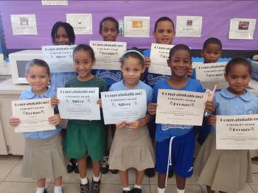
Since our Principal’s Certificate scheme started, students have been working hard to receive 10 points/checks/stars from their teachers in order to achieve the award. On Wednesday, another group of students were awarded Bronze certificates and a few have now achieved silver. Well done to all – keep up the positive attitude and commitment to our IB Learner Profile.

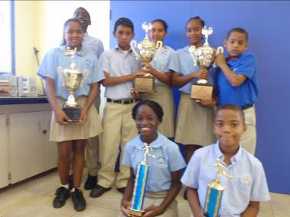
SPORTS AWARDS
Congratulations, once again, to SWALLOW who came first in our inter-house sports last Friday. Special congratulations, also, to our Champion Girl – Jordae Scott (Y6W) and our Champion Boy Vinton Wedderburn (Y5G). We have high hopes for them in the upcoming Inter-Primary Sports.

“You win some, you lose some, but you always try again!”
Please turn over…more on the back…
Dates for your Diary

Mon., Feb 28th PTA Meeting – student presentations of their IB projects – come and see what our students are capable of – and have your questions and concerns about the projects answered.
Mon., Mar 7th –
Fri., Mar. 11th (Incl.) Half-term holiday
Mon., Mar. 14th Commonwealth Day
Fri., Mar. 25th Dress Down Day
Mon., Mar. 28th PTA Meeting
Thurs., Mar. 31st and
Fri., Apr 1st Inter-Primary Sports
Thurs. Apr.. 14th Student-led Conferences
Mon., Apr. 18th PTA Meeting
Thurs., Apr. 21st School closes for Easter break at 1pm

PTA Update
The PTA will be raffling the following at the meeting on Monday, Feb. 28th – tickets cost $5.
- 1 x Calphalon Unison Non Stick 5QT Dutch Oven Pot, Nylon Spoon and Kitchen Towel
- 2 x @$25 Gift Cards from A L Thompson
- 2 x $10 Gift Certificates from Barney’s Coffee and Tea Company
- 1 x $25 Gift Certificate from South Coast Bar and Grille

Please attend the meeting at 6:30pm, we will be hearing about IB projects from a selection of Y3 – 6 students and answering your questions about the topics.

Valentine’s Dress Down Day
We had a very special dress down day on February 14th for St. Valentine’s Day. Many children dressed down in red and many had hearts and flowers on their clothes, as necklaces etc. – it was a colourful day! The winners were Gabriella Ebanks, Y1H; Gresheena Stewart, Y2C; MelodyAllenger, Y4WE; and Kobe Hurlston, Y5R.

Clifton Hunter PTA
Please be advised that Clifton Hunter PTA will be having a blow out sale on Saturday from 7am – 2pm at the school’s uniform shop. Boys and Girls pants will be on sale for $10 (normally $20). Parents of Y6 students who will be attending Clifton Hunter are encouraged to take advantage of this opportunity.
IB Attitude of the Month…Confidence
You have brains on your head.
You have feet in your shoes.
You can steer yourself in any direction you choose.
You’re on your own.
And you know what you know.
You are the guy who’ll decide where to go!
Dr. Seuss

