

Keeping Connected
www.savannahprimaryschool.blogspot.com 11th February, 2011


Police Request to Parents
The police have asked me to remind parents that they should not be parking on the roadside leading up to the Old Post Office when they are collecting their children at the end of the day. This is causing a serious hazard to other road users and is “an accident waiting to happen.” The police have stated that parents who continue to park there will be prosecuted for Road Traffic offences.

Sporting News
Last Friday, February 4th our netball B team won their match against Truth for Youth. Well done, girls! This afternoon the A team will play Sir John A Cumber Primary and the B team will play against George Town Primary. Good luck!

School Sports Day
Please be reminded that the school sports day will be held at the Truman Bodden Sports Complex on Friday, February 18th.
Please note that we still have some house caps available – they cost $6 and are available from our Librarian, Miss Peart.

Field Trips and Visitors…
Our photos this week come from Y1 and Y5. Y1 visited Dolphin’s Cove as part of their IB Unit of Inquiry, Circle of Life. The children are learning about animals and their life cycles. They also had a talk from Ms. Erica from the National Trust.
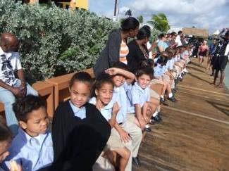
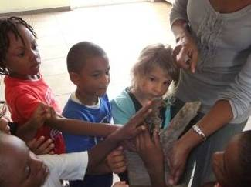

Year 5 have been having weekly sailing lessons for the last 6 weeks – a great time has been had and they have learnt a lot. They were also on the Nautilus Submarine last week.
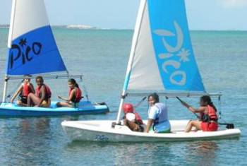
Personal Data Forms - Last call for updated information
Further to the letter sent home earlier this week, please be reminded that any final updates of personal information must be received by Miss Tricia in the office by Mon., Feb. 14th. We are constantly finding that the phone numbers we have for contacts are incorrect. If you, or your emergency contact person, have changed phone numbers in the last few months, please ensure that we have your new number.
IB Attitude of the Month…Confidence
"Confidence comes not from always being right, but from not being afraid to be wrong."

Art @ the Governor’s
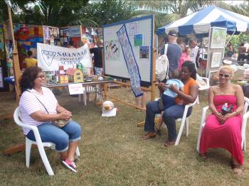
Many thanks to Mrs. Eden for her work in putting together a display of art for this wonderful event. The school bus was used to transport the artwork and boards to the location – our thanks to Mr. Derrick for his support. Thanks also to Mrs. Kinghorn, Miss Williams, Mrs. Christian, Miss Gopaul, Miss Simpson, Mrs. Waysome, Miss Seymour, Mr. Roberts, Mr. Clarke and Mrs. Julia Ebanks for taking their turn at helping to set up, dismantle and attend to the display throughout the day.
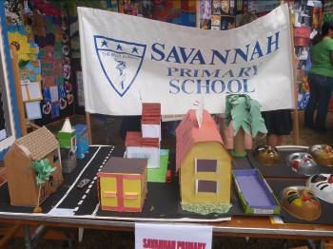
The school received an 'Honourable Endeavour' award for a piece titled 'Our Community' by Year 2 students.

Thank you…
…to Omar Fellows (Y6D); Kobe Hurlston (Y5R) and Chanelle Scott (Y6W) for donating books to the library.

Well Done…
…to Miss Simpson who has just graduated with an MA in New Literacies from Sheffield University.
…to Ronald Eden (1H); Gabriella Ebanks (1H); Amin Palmer (2W); James Anderson (2W); Isobel Chipp (1K); Chad Hernandez (2C); Holly McLean (2C); Taylor McElroy (2C); and Yeahlina Robinson (2C) for consistently showing good IB attitudes.
…to Khyla Oliver (1K); Erika Scotland (1K); Charles Clifford (1K); Felicia Clarke (3N); Nicholas Franco (3N); Jennay Comacho (3N); and Rochell Foster (5G) for showing enthusiasm for learning.
…to Dequan Smith (3W); Shezarie Thompson (3W); Arianna Dinnall (3W); Nazia Jacques (3W); Kaidi McField-Jackson (3W); Sascha Broderick (5R); Jasmine Brooks (4C); Dreshna James (4C); Leah Ebanks (3N); Vitoria Buttrum (5G); Hayley Samuels (5G); and Victorious Ebanks (4E) for being committed to helping others learn.
…to Ashleigh Brooks (4E); and Roberta Christian (5G) for taking a risk with learning.
…to Janae McKenzie (4E) for not giving up and trying everything.

Dates for your Diary
Mon., Feb. 14th Special VALENTINE”S Dress Down Day - $5 + prizes will be awarded.
Tues., Feb. 15th The 100th Day of School
Fri., Feb. 18th School Sports Day
Wed., Feb. 23rd Pinning of class representatives on the School Council at assembly
Fri., Feb. 25th Dress Down Day – $2
Mon., Feb 28th PTA Meeting
Mon., Mar 7th –
Fri., Mar. 11th (Incl.) Half-term holiday
Mon., Mar. 14th Commonwealth Day
Fri., Mar. 25th Dress Down Day
Mon., Mar. 28th PTA Meeting
Thurs., Mar. 31st and
Fri., Apr 1st Inter-Primary Sports
Thurs. Apr.. 14th Student-led Conferences
Mon., Apr. 18th PTA Meeting
Thurs., Apr. 21st School closes for Easter break at 1pm

