

Keeping Connected
www.savannahprimaryschool.blogspot.com 4th February, 2011


Police Request to Parents
The police have asked me to remind parents that they should not be parking on the roadside leading up to the Old Post Office when they are collecting their children at the end of the day. This is causing a serious hazard to other road users and is “an accident waiting to happen.” The police have stated that parents who continue to park there will be prosecuted for Road Traffic offences.

Sporting News
Well done to all our football players for their dedication this season. Unfortunately, the A team did not get through the semi-final stage of the Consolation Cup so both teams are now finished for this year.

Last Friday, January 28th was a mixed bag for our netballers. The A team won their game against Cayman Prep 10:4 but the B team narrowly lost to John A Cumber Primary School. Well done to all for their effort!

School Sports Day
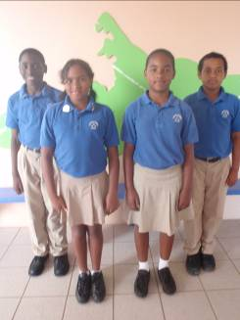
Preparations are underway for the school sports day which will be held at the Truman Bodden Sports Complex on Friday, February 18th. This week’s featured house is Nightingale. Pictured here (left to right) are their representatives. Jordan Scott (House Captain); Cassiedy Davis-Quintero (House Captain); Tianna Ramgeet (Deputy House Captain) and Joseph McLaughlin (Deputy House Captain).

Please note that we still have some house caps available – see the back of this newsletter for details.

MAN O’ WAR will be conducting their run-offs on Tues., Feb. 8th – students in Man o’ War must wear their PE kit that day.

Field Trips and Visitors…
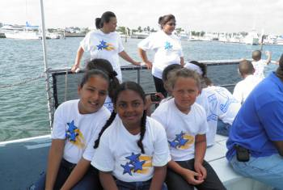
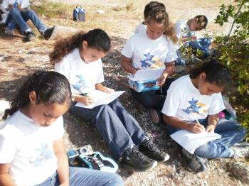
This morning, Fri., Feb. 4th, Year 5 are going on a trip on the Nautilus Submarine as part of their IB Unit of Inquiry on Ecosystems. Their presentation project for this terms will involve them in creating a presentation for the Minister of Health, Environment, Youth, Sports and Culture which voices either their concerns for or their support of the proposal to allow mega yachts into the North Sound. The presentation should refer to the mangroves and reef which may be affected by the building of a Marina. This project allows the students to explore the fragile ecosystems of the North Sound in a real context. It involves them in research, presentation skills, thinking, presenting an argument and finally, making their presentation and answering questions on it. This interactive, hands-on, relevant learning will enhance their abilities as confident and responsible citizens who can effectively contribute their views and ideas.

Presentation to PTA Funds
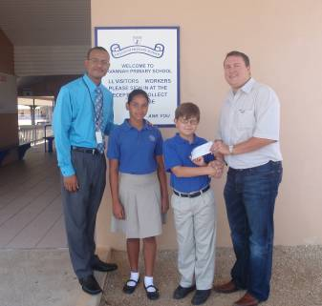
Many thanks to Mr. Matthew Wight of Papa John’s for his generous donation of CI$4000 to the PTA to assist with the funding of the Year 6 Trip to Cuba in June. The money was raised by his company through an annual Golf Tournament. He presented the cheque to Head Boy, Ethan Watler and Deputy Head Girl, Joelyn Scott. Mr. Richard Christian represented the PTA at the presentation.

Thank you…
…to Lucas, Challen and Roberta Kelehar for their donation of books for the library.

Well Done…
…to Rosheed Mowatt (Y4C), who handed in a ring that he found in the corridor. If anyone has lost a ring, please come to the Principal’s office to collect it.
…to Jeron Mills (Y1H) for showing a caring attitude to a fellow student.

Cayman Wildlife Rescue
The National Trust for the Cayman Islands is encouraging all to watch out for baby birds in difficulty this nesting season. If you find one and are unsure of what to do please contact Cayman Wildlife Rescue on their hotline 917-BIRD (2473). Do not attempt to care for wild birds yourself – let the experts handle it. You can find out more information about the service on www.caymanwildliferescue.org .

Dates for your Diary
Mon., Feb. 7th Minister for Education will be visiting the school in the afternoon.
Mon., Feb 7th; Thurs., Feb. Year 1 students visit the Botanic Park
10th and Fri., Feb. 11th Blue Iguana Recovery Programme
Mon., Feb. 14th Special VALENTINE”S Dress Down Day - $5 + prizes will be awarded.
Tues., Feb. 15th The 100th Day of School
Fri., Feb. 18th School Sports Day
Wed., Feb. 23rd Pinning of class representatives on the School Council at assembly
Fri., Feb. 25th Dress Down Day – $2
Mon., Feb 28th PTA Meeting
Mon., Mar 7th –
Fri., Mar. 11th (Incl.) Half-term holiday
Mon., Mar. 14th Commonwealth Day
Fri., Mar. 25th Dress Down Day
Mon., Mar. 28th PTA Meeting
Thurs., Mar. 31st and
Fri., Apr 1st Inter-Primary Sports
Thurs. Apr.. 14th Student-led Conferences
Mon., Apr. 18th PTA Meeting
Thurs., Apr. 21st School closes for Easter break at 1pm
IB Attitude of the Month…Confidence
“Only as high as I reach can I grow; Only as far as I seek can I go;
Only as deep as I look can I see; Only as much as I dream can I be.”
Have the confidence to reach higher, seek further, look deeper and dream bigger! You CAN do it!

